iSQAPER 1st Scientific Board meeting

1. Dates

The 1st iSQAPER - Scientific Board meeting will be held from Tuesday 7 February 2017 - Thursday 9 February 2017 in Madrid.

Temporary program:

7 February : morning - arrival hotel  
                    afternoon - 13:00 - 17:00 preliminary talks with WP leaders - Hotel or UPM  
8 February:  9:00 - 18.00 - Scientific Board meeting with EU-delegates - Hotel  
9 February: 9.00 - 13:00 - Evaluation meeting with WP leaders - Hotel or UPM  
                   afternoon: departure

The locations of the preliminary talks and the evaluation meeting are still subjects of discussion.

[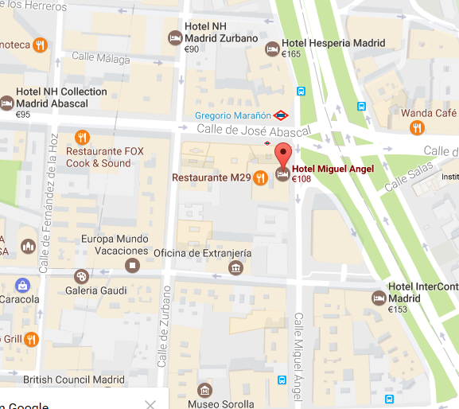](https://www.google.nl/maps/place/Hotel+Miguel+Angel/@40.4364065,-3.6954378,16z/data=!4m5!3m4!1s0x0:0x600c54d812844f9d!8m2!3d40.4376536!4d-3.6914571)2. Location

Madrid, Spain   ( Official tourism website: <http://www.esmadrid.com/en/tourist-information-centres>) 

3. Venue

Hotel Miguel Angel ([Hotel website)](http://www.hotelmiguelangel.com/en/contact/)  
Address: C/Miguel Angel 29-31 – 28010 MADRID  
Tel: +34 91.442.00.22

The meeting will be in the hotel.

4. Lodging

Ana Iglesias, our local organiser of this meeting, has already made appointments with the management of this hotel about the lodgings. Rooms are available at a rate of 125€ or 135€ with breakfast included. You can make your reservation by filling in the hotel reservation form.

Participants have to book their room directly. The group reservation will held till the first of February. Any reservation after this date will be on request, subject to the Hotel’s availability. Reservations can be made by filling in the hotel reservation form and email it to: [reservas.miguelangel@grupobluebay.com](mailto:reservas.miguelangel@grupobluebay.com)

Coffee and lunch will be included. UPM will pay for the rental room. The costs of coffee, lunch and dinner will be included in a registration fee.

 5. Food

A lunch is provided  during the whole day meeting (8 February

The other days you have to organize your own lunch. Dinners will need to be arranged by yourself.

Special food arrangements has to be organized at place.

6. Travelling

Travel options from airport to hotel or university can be found in the annex of this document.

7. Local Money

- The local currency is Euro, money machines are available throughout Madrid.  
  
- In the hotels Credit Cards can be used or cash.

8. Local Weather

Weather for Madrid in February: See: [http://www.holiday-weather.com/](http://www.holiday-weather.com/madrid/averages/february/)

9. Contact

Local organiser:

Ana Iglesias: [aiglesias.upm@gmail.com](mailto:aiglesias.upm@gmail.com)

Project coordination team:

**Coen Ritsema:** [coen.ritsema@wur.nl](mailto:coen.ritsema@wur.nl)  
**Violette Geissen**: [violette.geissen@wur.nl](mailto:violette.geissen@wur.nl)  
**LuukFleskens**: [luuk.fleskens@wur.nl](mailto:luuk.fleskens@wur.nl)

Annex: travel options

iSQAPER 1st Scientific Board meeting

**1. Directions from Airport to the UPM**

Technical University of Madrid (UPM) - School of Agriculture

Escuela Técnica Superior de Ingeniería Agraria, Alimentaria y de Biosistemas (ETSIAAB)

From Terminals 1, 2, 3 and 4

1. Taxi, 30 €, 20 min
2. Metro, **Line 8** to “Nuevos Ministerios” (4 stops), change to **Line 6** Circular to "Ciudad Universitaria" (4 stops). 4 €, about 30 min

Walking from the Metro "Ciudad Universitaria" to the ETSIAAB-UPM. 2 min



**2. Directions from Airport to Hotel Miguel Angel**

From Terminals 1, 2, 3 and 4

1. Taxi, 30 €, 20 min
2. Metro, **Line 8** to “Nuevos Ministerios” (4 stops), 15 min, 4 €
3. Change to **Line 10** to "Gregorio Marañon" (1 stop). proce included in the airport ticket
4. Alternatively, walk from metro “Nuevos Ministerios” to the hotel, 15 minutes

Walking from the Metro "Nuevos Ministerios" or metro "Gregorio Marañon" to Hotel

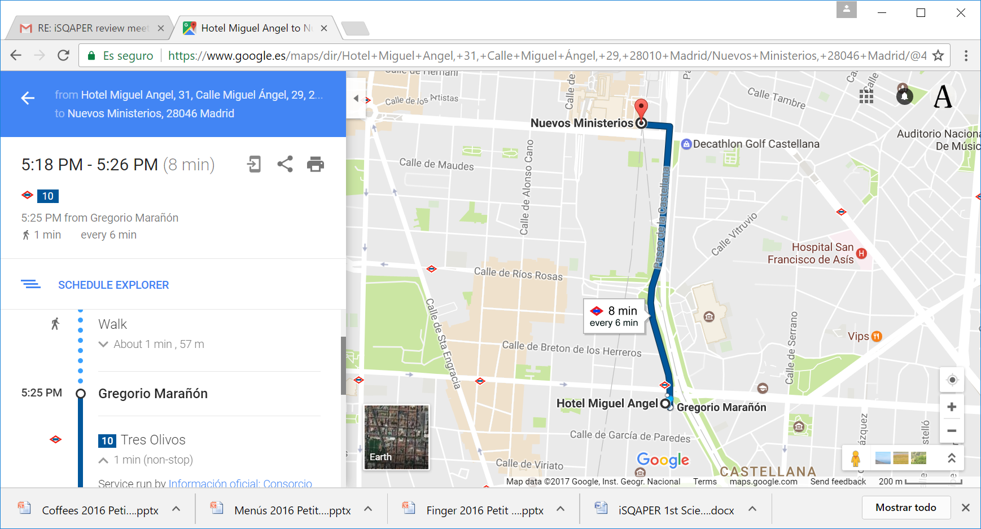

**Local contact**

Ana Iglesias, Dept Agricultural Economics, UPM, Madrid

Tel: +34 609 613 428; +34 913365794

ana.iglesias@upm.es